

Department of Computer Science and Software Engineering

INTERNATIONAL ISLAMIC UNIVERSITY ISLAMABAD

Semester Spring 2024

**Lab Report 3**

Operating System

Date: 27 Mar, 2024

Submitted by:

**OSAMA MALIK**

4319-FCIT/BSSE/F21

Submitted to:

**Mr. Niaz Muhammad**

**Linux Commands**

1. **for i in {1..8} ; do echo $i sleep 1 done**

| Loop and Print Numbers |

This command uses a for loop to iterate through numbers from 1 to 8. Inside the loop, it prints the current value of i using echo and then pauses for 1 second using sleep 1. You might use this for simple counting or creating timed delays in a script.

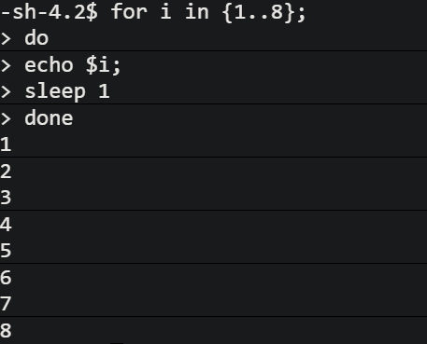

1. **for file in *.txt; do echo $file sleep 1 done**

| Loop and Print Text Files |

This command iterates through all files with the .txt extension in the current directory. Inside the loop, it prints the filename using echo and then pauses for 1 second using sleep 1. This can be useful for listing text files or creating a timed process for working with them.

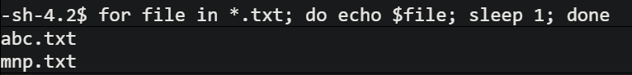

1. **for file in *.mp3; do echo $file sleep 1 done**

| Loop and Print Text Files |

This command iterates through all files with the .mp3 extension in the current directory. Inside the loop, it prints the filename using echo and then pauses for 1 second using sleep 1. This can be useful for listing text files or creating a timed process for working with them.

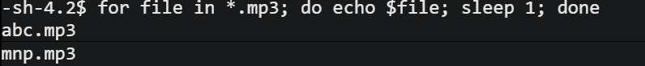

1. **ls -l $(locate abc.txt)**

| List Details of Located File |

This command combines locate and ls -l. First, locate abc.txt searches for the file named "abc.txt" using the system's file location database. Then, the output (the file path) is captured within parentheses $() and passed to ls -l to display detailed information about the located file, including permissions, owner, group, and size. Use this to get detailed file information after a quick search using locate.

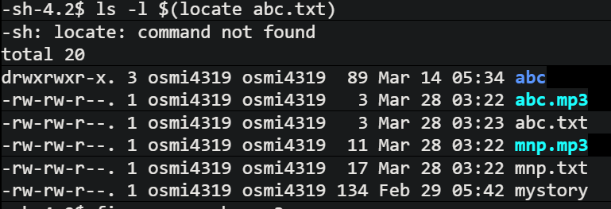

1. **find -name mnp.mp3**

| Find Specific File |

This command uses find to search for a file named exactly "mnp.mp3" in the current directory and its subdirectories. It's useful for locating a specific file by its complete name.

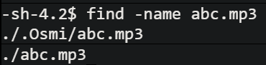

1. **find -name 'abc*'**

| Find Files with Matching Patterns (Wildcard) |

This command searches for all files that start with "abc" (including any characters after "abc") in the current directory and its subdirectories. The asterisk (*) acts as a wildcard to match any characters. Use this to find groups of files with similar names.

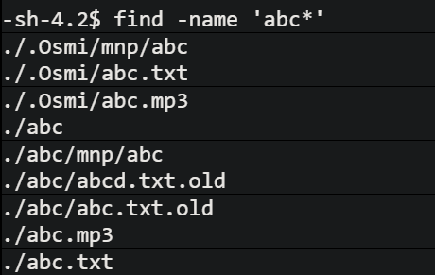

1. **find -name 'mnp*'**

| Find Files with Matching Patterns (Wildcard) |

Similar to command 5, this searches for all files that start with "mnp" (including any characters after "mnp") in the current directory and its subdirectories.

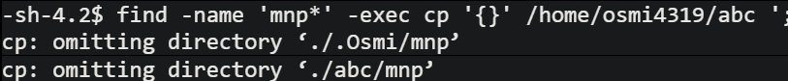

1. **find -name 'mnp*' -exec cp /home/osmi4319 {} \;**

| Find and Copy Files (Caution Advised) |

This command is more complex. It searches for files starting with "mnp*" and then attempts to copy them to the directory /home/osmi4319. The -exec option allows executing a command (cp) on each found file, represented by {}. Warning: Be cautious with this command, as incorrect paths or file permissions can lead to unintended consequences. Ensure you have the necessary permissions and the destination directory exists before using it.

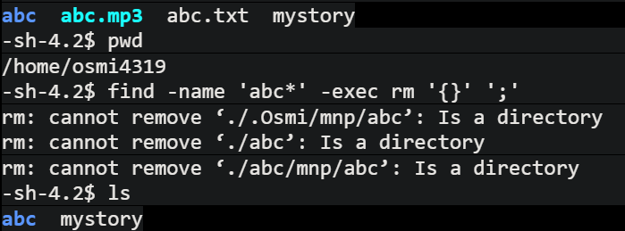

1. **for file in *.mp3; do rm -v $file; done**

| Loop and Delete MP3 Files (Caution Advised) |

This command iterates through all .mp3 files and deletes them one by one. The -v flag with rm provides verbose output, showing each file being deleted. Warning: Use extreme caution with this command, as deleted files cannot be easily recovered. Make sure you have a backup or are absolutely certain you want to delete the files before using it.

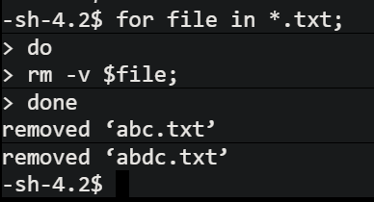

1. **find -type d | Find Directories**

| Find Directories |

This command searches for directories (folders) in the current directory and its subdirectories. It's helpful for listing or working with directories within your file system.

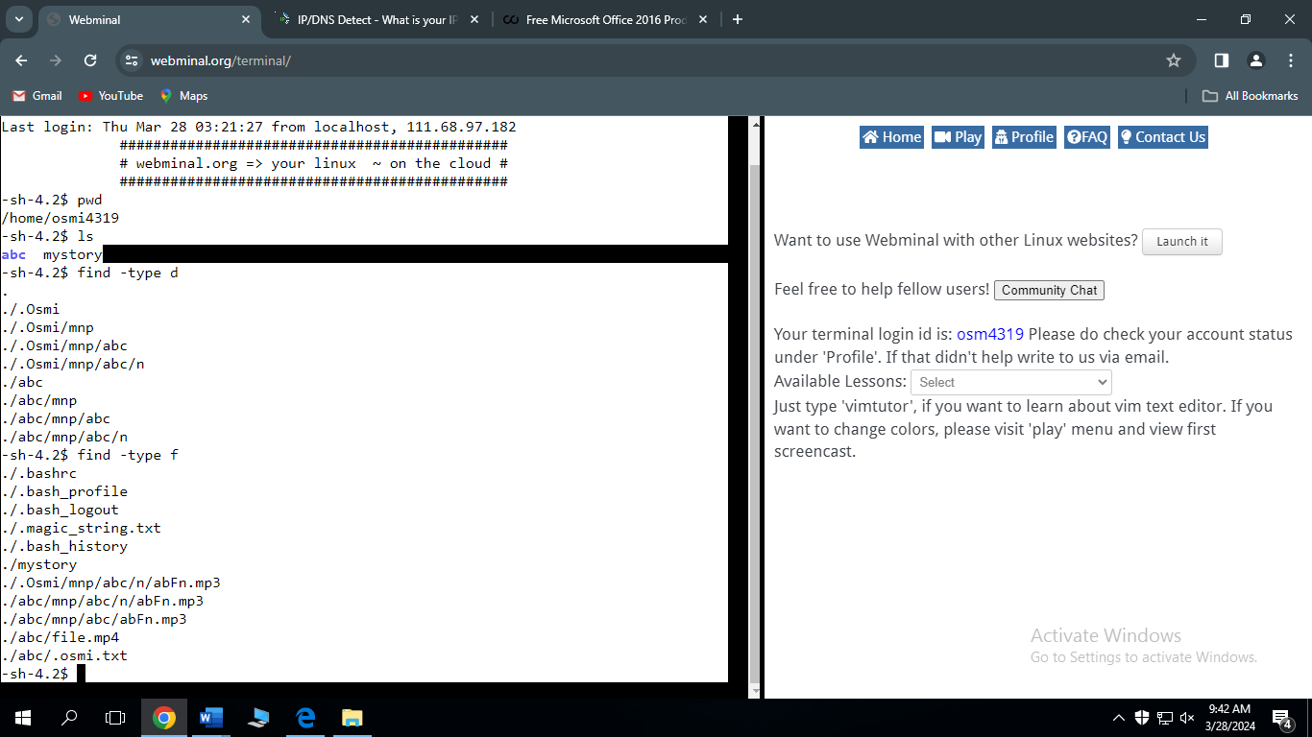

1. **find -type f**

| Find Files |

This command searches for regular files (not directories) in the current directory and its subdirectories. Use this to locate specific files or groups of files that are not directories.



******* End *******